**Game Rules**

4-6 players

In the game of ‘Judgement’, the humans form a voting committee in order to compete for a future life in another realm. These humans have been entrusted to question what is true, to refine who is worthy of the afterlife. Humans who must tell a lie have been temporarily tainted with sin, for the purposes of testing other humans. Players will score points depending on their ability to correctly judge other player’s experiences. With a clearer perception of their fellow human beings, they become closer to a higher consciousness, worthy of the afterlife.

**Set-up:**

You will need:

* 2 liar counters (red) and enough truth counters (green) to make up the number of players (e.g. 6 players will need 2 liar tokens and 4 truth tokens) placed into the counter bag
* 2 voting tokens each
* A character card placed in front of each player

Place the betting board and the question cards in the middle, separated into categories

**Example Set-up for 6 player game:**



Question Cards

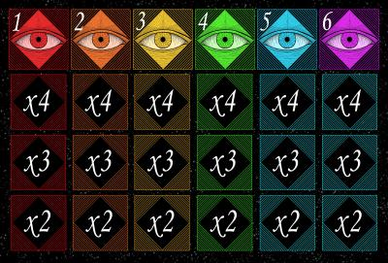

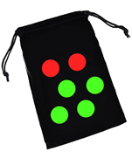



Voting Tokens

Counter bag containing Truth/Liar counters

Betting Board



Player Character Cards

**Gameplay:**

* Ensure all the truth and liar counters have been placed into the counter bag
* At the start of each round, each player takes it in turns to take a liar/truth counter out of the bag (keep this hidden from the other players!)
* One player at the start of the round must choose a question by taking a card from the top of any category pile and place it in the centre for all players to see. Players take turns to choose a card each round in a clockwise direction, youngest player chooses for the first round.
* Players must all answer the question on the card in the centre. If you have a liar counter (red) you must lie that round, if you have a truth counter (green) you must give a truthful answer to the question. Players answer the question in order of the number on their character card.
* After all answers have been given, players can discuss answers and question other players
* You are trying to discover the liars, make your judgement count!
* Players must vote for who they think is lying by placing their tokens on the betting board in the centre (players can vote at any time during the round, they do not have to wait until all answers have been given)
* Players will use two tokens to vote each round and may place both tokens on the same player or spread their tokens to bet on 2 separate players
* To vote, place your tokens under the number corresponding to the number in front of the player(s) you want to vote for. Once placed, you cannot move or add tokens.
* If you are the first person to bet on a player, place your tokens in the first slot under their number, if you are the second person to bet on a player, place your tokens in the ‘x3’ slot below their number and if you are third or later, place your tokens in the ‘x2’ box.

Scoring:

* The box you place your tokens in corresponds to the amount of tokens you will gain for guessing correctly:
* If your tokens are in the x4 box, you will gain 4 times the amount of tokens you placed on a player for a correct guess, if your tokens are in the x3 box, you will receive 3 times the amount of tokens you placed and if your tokens are in the x2 box, you will gain 2 times the amount you placed
* If you were a liar that round, you gain one token for each player who didn’t vote for you as the liar
* If you place tokens on a player who was telling the truth, you will lose all tokens placed on this player (liars who voted on truthful people in a round will have their tokens returned!)
* You will always keep 2 tokens, you can never run out of tokens

The game ends when each player has had a turn to choose a question card or when a player has hit the maximum number of tokens and there is no more tokens of their colour to collect. The player with the most tokens at the end of the game wins.